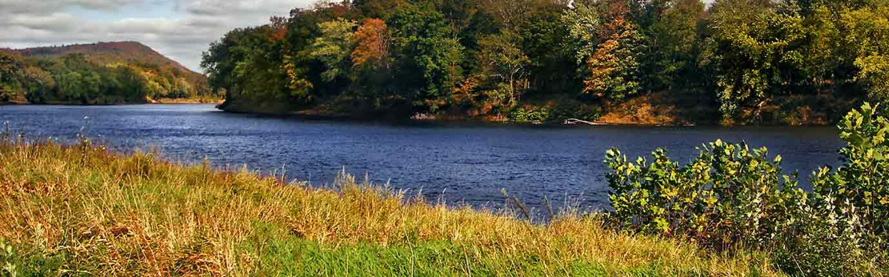

Delaware River Floodplain | Photo by Nicholas Tonelli

**Natural Floodplain Functions Alliance**

**Steering Committee Leadership**

**2025 Steering Committee Members**

|  |  |
| --- | --- |
| Name | Organization |
| |  | | --- | | Cameron Adams | | Chad Berginnis | | David Carlton | | David Conrad | | Lacey Davis | | Emily Donahoe | | Sarah Edwards | | Dave Fowler | | Meg Galloway | | Ian Grosfelt | | Mike Kline | | Larry Larson | | John McShane | | Vanessa Muñoz | | Brain Murphy | | Tanya Pelach | | Jessie Ritter | | Eileen Shader | | Velma Smith | | Marla Stelk | | |  | | --- | | The Nature Conservancy | | Association of State Floodplain Managers | | Association of State Floodplain Managers | | Association of State Floodplain Managers | | American Rivers | | National Wildlife Federation | | Southern Environmental Law Center | | Association of State Floodplain Managers | | Association of State Floodplain Managers | | National Association of Wetland Managers | | Consultant | | Association of State Floodplain Managers | | Environmental Protection Agency, Retired | | Hispanic Access Foundation | | River Network | | Affiliated Tribes of Northwest Indians | | National Wildlife Federation | | American Rivers | | PEW Research Center | | National Association of Wetland Managers | |

**2025 Emeritus Steering Committee Members**

|  |  |
| --- | --- |
| Name | Organization |
| |  | | --- | | David Carlton | | Dave Fowler | | Mike Kline | | Larry Larson | | John McShane | | |  | | --- | | Association of State Floodplain Managers | | Association of State Floodplain Managers | | Consultant | | Association of State Floodplain Managers | | Environmental Protection Agency, Retired | |

**2025 Federal Agency Liaisons**

|  |  |
| --- | --- |
| Name | Organization |
| |  | | --- | | Jeffry Herd | | Brian Killen | | Mary Margaret Jackson | | TBD | | TBD | | TBD | | TBD | | |  | | --- | | Federal Emergency Management Agency | | Federal Emergency Management Agency | | Federal Emergency Management Agency | | U.S. Army Corps of Engineers | | Fish and Wildlife Services | | National Oceanic and Atmospheric Administration | | Natural Resources Conservation Service | |